Project Design Phase-II
Data Flow Diagram & User Stories
Date | 12 July 2026
Team ID | SB_2026_NutriAssist_01
Project Name | NutriAssist — Personalized Nutrition Assistant
Maximum Marks | 4 Marks

Data Flow Diagrams
A Data Flow Diagram (DFD) is a visual representation of the information flows within a system. It shows how data enters and leaves the system, what processes transform it, and where it is stored. The diagrams below model NutriAssist, a MERN-stack nutrition tracking and recommendation web application.

Level 0 — Context Diagram
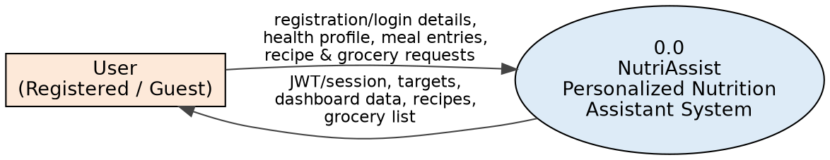
Fig 1: Context-level DFD — User interacting with the NutriAssist system

Level 1 — Detailed DFD
The context diagram is decomposed into four major processes — authentication & profile management, meal logging, recommendation calculation, and recipe/grocery-list generation — each reading from or writing to the relevant MongoDB collection (D1 User, D2 Food, D3 MealLog, D4 Recipe).
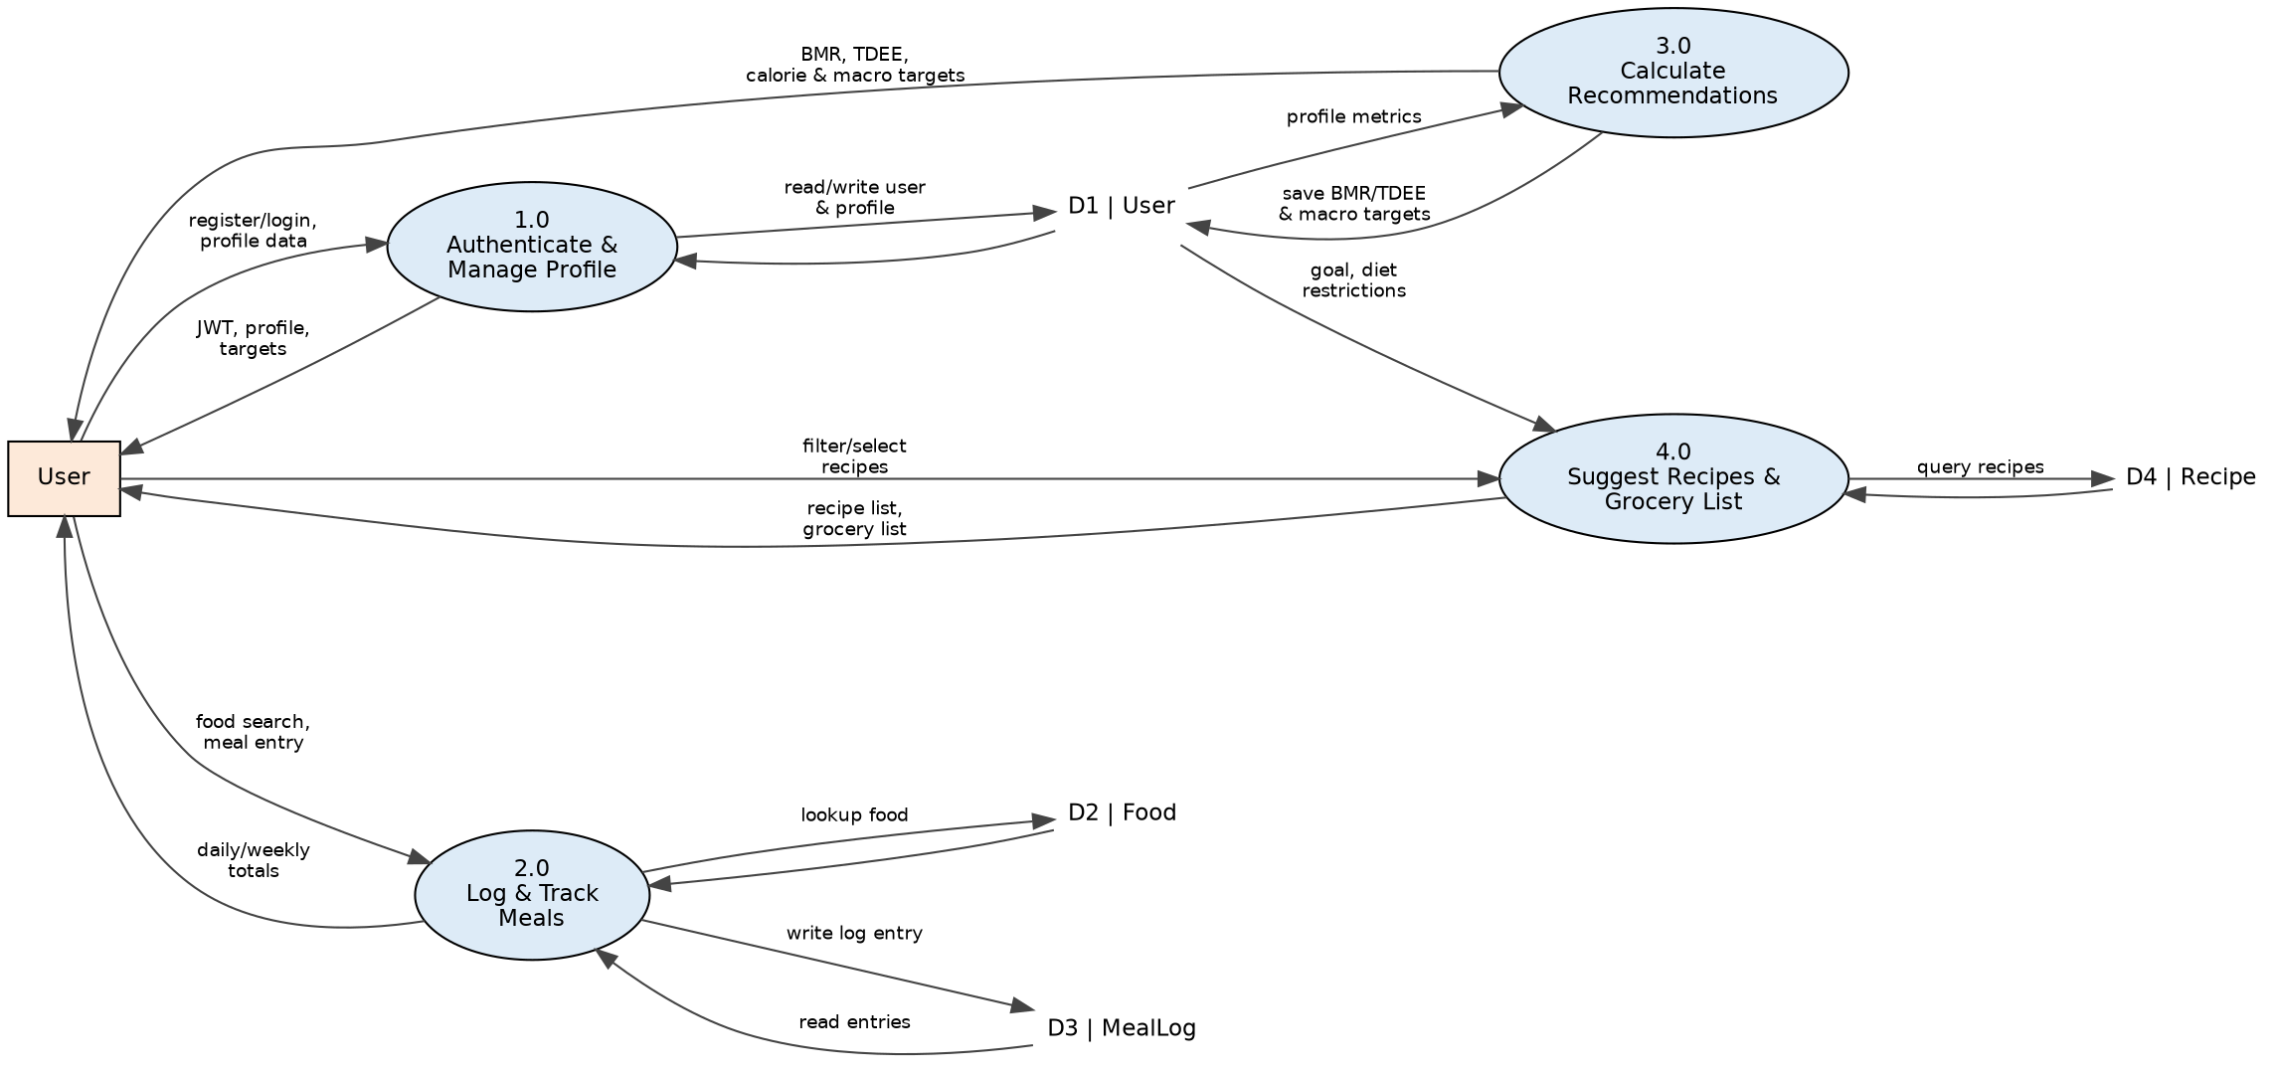
Fig 2: Level 1 DFD — NutriAssist core processes and data stores

User Stories
The table below lists the user stories for NutriAssist, grouped by user type and functional requirement (epic), covering the features implemented in the current build as well as the administrator capabilities planned as a future enhancement.
User Type | Functional Requirement (Epic) | User Story Number | User Story / Task | Acceptance Criteria | Priority | Release
Customer (Registered User) | Registration | USN-1 | As a user, I can register for the application by entering my name, email, and password. | I can create an account and land on my dashboard after registering. | High | Sprint-1
 |  | USN-2 | As a user, I want my password stored securely so my account cannot be compromised. | Passwords are hashed with bcrypt (salted) before being saved; plain text is never stored. | High | Sprint-1
 | Login | USN-3 | As a user, I can log into the application by entering my registered email and password. | I receive a JWT and am redirected to my dashboard on success. | High | Sprint-1
 |  | USN-4 | As a user, I want to stay logged in without re-entering my credentials on every visit. | The JWT is stored and automatically attached to every request until it expires or I log out. | Medium | Sprint-1
 | Health Profile | USN-5 | As a user, I can enter my age, gender, height, weight, activity level, and goal. | My profile is saved and my BMR/TDEE/macro targets are recalculated automatically. | High | Sprint-1
 |  | USN-6 | As a user, I can specify my dietary restrictions. | My restrictions are saved and later used to filter recipe suggestions. | Medium | Sprint-2
 | Meal Logging | USN-7 | As a user, I can search a food database and log a food item with a quantity in grams. | The entry appears under the correct meal type and date with computed calories/macros. | High | Sprint-1
 |  | USN-8 | As a user, I can view and delete a previously logged meal entry. | The entry is removed and the daily totals update immediately. | Medium | Sprint-2
 | Dashboard | USN-9 | As a user, I can view today's calories and macros against my targets on a dashboard. | The dashboard shows progress for calories, protein, carbs, and fat. | High | Sprint-1
 |  | USN-10 | As a user, I can view a 7-day calorie trend chart. | The chart displays zero-filled daily totals for the 7 days ending today (or a chosen date). | Medium | Sprint-2
 | Recommendations | USN-11 | As a user, I can calculate my BMR, TDEE, and macro targets from my profile. | The results screen shows BMR, TDEE, and a daily calorie and macro breakdown. | High | Sprint-1
 |  | USN-12 | As a user, I can save my calculated targets to my profile. | Saved targets persist and are reflected on the dashboard. | High | Sprint-1
 | Recipes & Grocery List | USN-13 | As a user, I can browse recipe suggestions filtered by meal type, goal, and diet. | The recipe list updates to match the selected filters. | Medium | Sprint-2
 |  | USN-14 | As a user, I can generate a grocery list from one or more selected recipes. | Ingredients from all selected recipes are aggregated into a single list. | Low | Sprint-3
 | Resources | USN-15 | As a user, I can read educational articles on nutrition fundamentals. | The resources page loads and displays the article content. | Low | Sprint-3
 |  | USN-16 | As a user, I can browse a directory of nutrition professionals. | The directory page lists professionals with their contact details. | Low | Sprint-3
Administrator | Content Management | USN-17 | As an administrator, I can add, edit, or remove entries in the food database. | Changes are reflected immediately in food search results used for meal logging. | Medium | Sprint-4 (Planned)
 |  | USN-18 | As an administrator, I can add, edit, or remove entries in the recipe database. | Changes are reflected immediately in recipe suggestions and grocery-list generation. | Medium | Sprint-4 (Planned)

